



|  |
| --- |
|  |
|  |

| Related Artifacts | |
| --- | --- |
| Ref. | Name |
|  |  |
|  |  |

|  |  |
| --- | --- |
| Abbreviations and Acronyms | |
| XE | Express Edition |
| MB | Megabytes |
| PC | Personal Computer |
| RHEL | Red Hat Enterprise Linux |
| RAM | Random Access Memory |
| VM | Virtual Machine |
| HTTPD | Hyper Text Transfer Protocol Daemon |
| SSL | Secure Sockets Layer |
| IP | Internet Protocol |
| RDP | Remote Desktop Protocol |
| SSH | Secure Shell |
| SQL | Structured Query Language |
| JDBC | Java Database Connectivity |

| REVISION HISTORY | | | | | |
| --- | --- | --- | --- | --- | --- |
| Ver. | Description of Change | Author | Date | Approved | |
| Name | Effective Date |
| 1.0 | Guide created | Olga Nekrutkina | 20-Dec-2019 |  | dd-mmm-yyyy |
| 1.1 | “Postgres-specific Acuity installation” section added | Olga Nekrutkina | 17-Feb-2020 |  |  |
|  |  |  |  |  |  |

Contents

1 Introduction 4

2 Local Acuity Installation (Docker Version) 4

2.1 How to Install Oracle XE database for Windows 4

2.2 How to Install and Configure Docker 6

2.2.1 Docker Installation 6

2.2.2 Docker Configuring 7

2.2.3 Running VA-Hub and AdminUI 8

3 Cloud Acuity Installation (Azure) 8

3.1 Requirements 9

3.1.1 Hardware 9

3.1.2 Oracle Database 9

3.1.3 Upload Database Dump 10

3.1.4 Config Files 10

3.1.5 Configuration Changes 10

3.2 Credentials 10

3.3 Deployment Process 11

3.3.1 Stop Unnecessary Services 11

3.3.2 Install Necessary Services 11

3.3.3 Check Java Version after Installation 11

3.3.4 Delete rpm File 11

3.3.5 Check Database Existence and Create "oracle" Host 11

3.3.6 Create Folders 11

3.3.7 Copy war-files and conf-files to Directories and Grant Permissions 11

3.3.8 Configure the SSL and the Apache HTTPD Web Server 12

3.3.9 Create Services and Check Their Existence 12

3.3.10 Start Services and Check Them 12

4 Postgres-specific Acuity Installation 12

5 System Maintenance (Azure) 13

5.1 Backup and Recovery 13

5.2 Application Redeployment 14

5.2.1 Requirements 14

5.2.2 Credentials 14

5.2.3 Redeployment Process 15

5.3 Logging 16

5.4 Applications Restart 16

5.5 Database Restart 17

5.6 Apply Database Changes (Flyway) 17

5.7 Apply Certificates 17

6 Troubleshooting 18

6.1 Redeployment: Issue with -Xmx -Xms Parameters 18

6.2 Other Frequent Issues 18

6.2.1 Whitelabel Error Page 18

6.2.2 Connection Issue When Getting to a Jumpbox via RDP 18

6.2.3 Connection Issue When Getting via SSH to a Server in Azure Cloud 18

6.2.4 Connection Issue When Getting to the Database in Azure Cloud 18

6.2.5 Applications Cannot Connect to the Database 18

6.2.6 Database ID is not Available 18

6.2.7 Unstable Connection to Oracle Database and Errors in '/u01/app/oracle/diag/rdbms/react/react/trace/alert_react.log' 19

Appendix A. Building Docker Images 20

Appendix B. ‘Kitematic’ - Graphical Interface for Docker 22

Appendix C. Truncating filter tables (FILTER_*, FILTER_*_PKS) 23

Appendix D. Maintaining the Database (Dumps, Creation, Deletion) 25

# Introduction

Acuity system is intended to perform effective analysis of ongoing clinical trial information, while providing Integrated and interactive views of the clinical data. System includes several applications, such as:

* VA-Hub - a web application showing the clinical trials data visualizations;
* AdminUI - a web application supporting clinical studies by editing dataset mappings and conversion rules.
* VA-Security – a web application providing authentication/authorization for application users.

Current document describes system installation process, system maintenance, and troubleshooting.

# Local Acuity Installation (Docker Version)

In order to install Acuity locally, you should install: 1) the database and 2) Docker with VA-Hub and AdminUI images.

**Note**: There is no VA-Security component in the local version.

## How to Install Oracle XE database for Windows

Perform the following actions:

1. Download “Oracle Database 18c Express Edition for Windows x64” from Oracle Database Express Edition (XE) Downloads page (<https://www.oracle.com/technetwork/database/database-technologies/express-edition/downloads/index.html>).

**Note**: You need to sign up / sign in with your Oracle account to be able to download it.

1. Extract the contents of the zip archive and run setup.exe.
2. Follow the installation instructions:

* Select destination folder. It will be automatically stored as ORACLE_HOME environment variable;
* Set **AND REMEMBER** admin password, when prompted;
* Check whether you are able to connect to the database with a system user:
* User: SYSTEM
* Password: the password you set during the installation
* Hostname: 127.0.0.1
* Port: 1521
* SID: xe

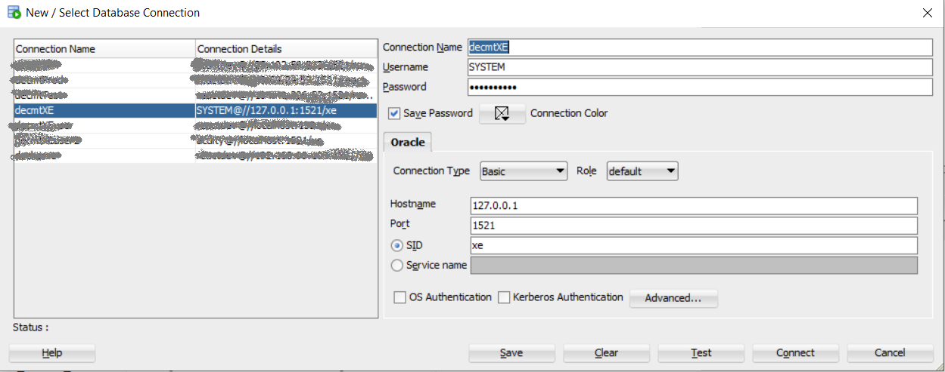

1. Run flyway migration:

* Download flyway command line tool (https://flywaydb.org/documentation/commandline/);
* Copy .jar file for the migration (e.g. ‘react-flyway-5.0-SNAPSHOT.jar’ provided by EPAM) to the /jars folder in the flyway command line tool;
* From the flyway folder execute the following command in the command line tool:

‘flyway baseline’

and copy the baseline version (see the picture below);

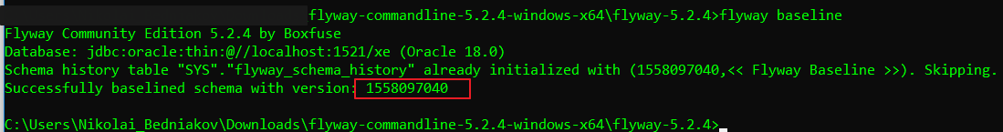

* Set connection details in the configuration file at /conf/flyway.conf:
* **Note**: The following settings are appropriate for the initial run only.

flyway.url=jdbc:oracle:thin:@//localhost:1521/xe

flyway.user=sys as sysdba

flyway.password=*[system password you set during the installation]*

flyway.driver=oracle.jdbc.OracleDriver

flyway.locations=classpath:flyway/sys

flyway.baselineVersion= 1558097040

flyway.baselineOnMigrate=true

* Put Oracle jdbc driver (ojdbc8.jar) to the /drivers folder in the flyway command line tool.
* **Note**: You should find “Oracle Database 18c (18.3) JDBC Driver & UCP Downloads” for Oracle XE 18c on the Oracle site, probably at https://www.oracle.com/technetwork/database/application-development/jdbc/downloads/index.html
* From the flyway folder execute the following commands in the command line tool:
* "flyway info" to check status (database user/password from step#3 is required);
* "flyway migrate" to apply migrations (database user/password from step#3 is required);

**Note**: After migration finishes you will see the following status message after running “flyway info” command:

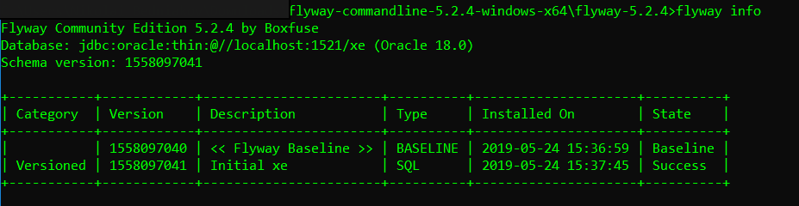

1. Copy Acuity dump (local_acuity_ACLS_final.dmp) to the DATA_PUMP_DIR folder.

**Note**: Most probably, it will be at the [ORACLE_HOME]\admin\xe\dpdump\ directory. If something changes in next Oracle releases, the path can be obtained with following query:

SELECT directory_name, directory_path FROM dba_directories WHERE directory_name = 'DATA_PUMP_DIR';

1. Execute ‘upload_dump.bat’ batch file from the same folder as the dump file using command prompt.

**Note**: Run it as administrator.

1. Try to connect to the database with acuity/react credentials. You should be able to connect and view data tables.

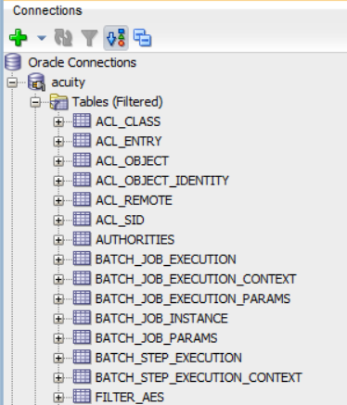

**Note**: You can check it with following query:

Select * from result_study;

## How to Install and Configure Docker

### Docker Installation

Download Docker Desktop for Windows from <https://hub.docker.com/editions/community/docker-ce-desktop-windows>. When the installation finishes, Docker starts automatically.

### Docker Configuring

1. Open Docker context menu from the taskbar and select **Settings** item.

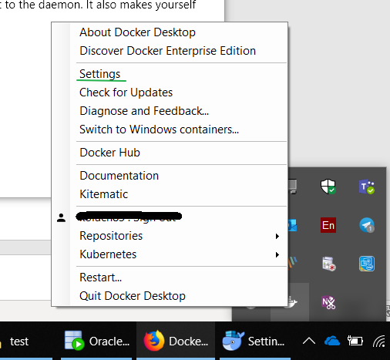

1. In **Settings** window go to **Shared Drives** tab and select there drive C:/.

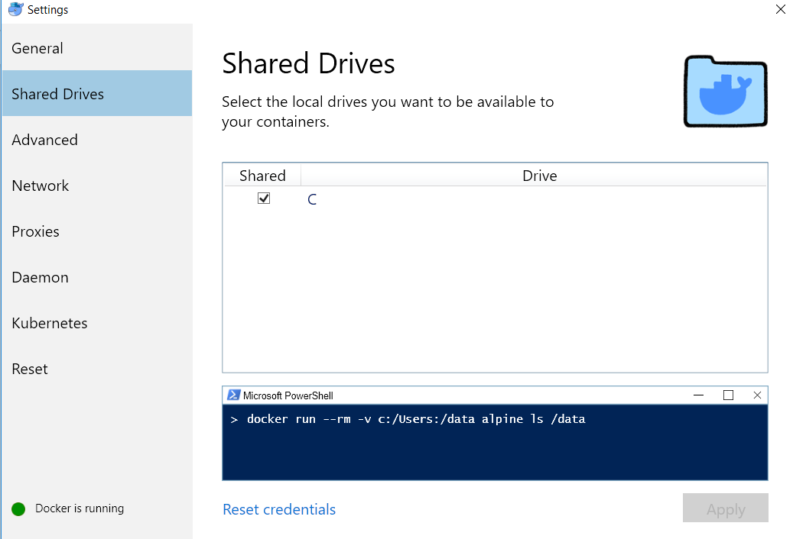

1. Go to **Advanced** tab. Set there available resources for Docker (at least 5000 MB for Memory and 2500 MB for Swap).

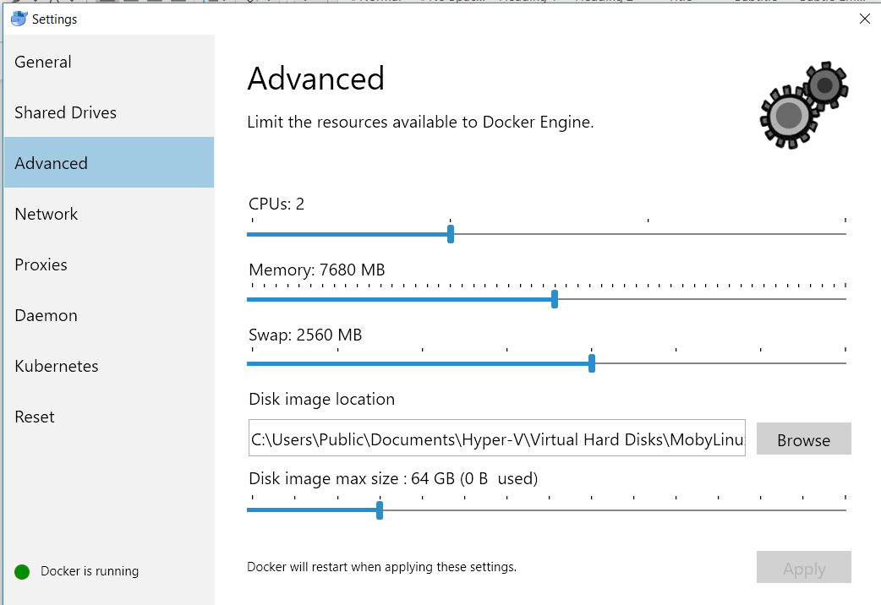

### Running VA-Hub and AdminUI

1. Make sure that Oracle XE is running on your PC (see How to Install Oracle XE database for Windows section).
2. Download ‘Docker Archive.zip’ with Docker images and test dataset, and extract it into the selected folder (e.g. to C:/Local Acuity).

**Note**: Later “docker load” and ”docker-compose up” commands should be executed from this folder.

**Note**: See Building Docker Images section for additional information.

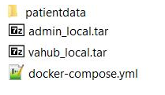

1. Run the whole application via docker compose:
   1. Open command line (Win+R, type cmd, press Enter). Switch to the required folder using “cd” command. e.g.:

cd C:/Local Acuity

* 1. Load images from tar archives:

docker load < vahub_local.tar

docker load < admin_local.tar

* 1. Start application:

docker-compose up

To run VA-Hub, go to <http://localhost:8000/> in Chrome.

To run AdminUI, go to <http://localhost:9090/> in Chrome.

# Cloud Acuity Installation (Azure)

This section introduces you to the deployment to the RHEL (Red Hat Enterprise Linux)/CentOS ver.7 (Apache httpd 2.4) environment.

## Requirements

### Hardware

Check that application VM has at least 16Gb RAM. Execute top from command line.

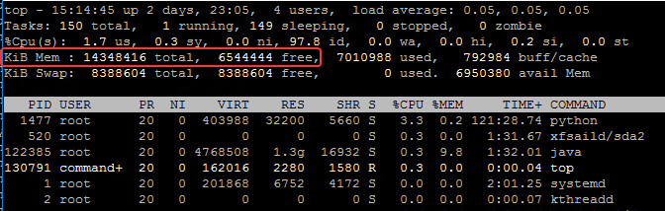

### Oracle Database

Check that Oracle database is installed on the database VM and working.

Oracle user’s .bash.rc:

# User specific aliases and functions

export ORACLE_HOME=/u01/app/oracle/product/18.0.0/dbhome_1

export ORACLE_BASE=/u01/app/oracle/

export PATH=$PATH:$ORACLE_HOME/bin

export ORACLE_SID=react

When you now start a new session as the oracle user, the environment variables are set correctly:

[oracle@athenexreactd01 ~]$ env | grep -i ora

USER=oracle

ORACLE_SID=react

ORACLE_BASE=/u01/app/oracle/

MAIL=/var/spool/mail/oracle

PATH=/usr/local/bin:/bin:/usr/bin:/usr/local/sbin:/usr/sbin:/u01/app/oracle/product/18.0.0/dbhome_1/bin:/home/oracle/.local/bin:/home/oracle/bin

PWD=/home/oracle

HOME=/home/oracle

LOGNAME=oracle

ORACLE_HOME=/u01/app/oracle/product/18.0.0/dbhome_1

Oracle user can now find the dbca:

[oracle@athenexreactd01 ~]$ which dbca

/u01/app/oracle/product/18.0.0/dbhome_1/bin/dbca

It also means that you can connect to sqlplus:

[oracle@athenexreactd01 ~]$ sqlplus / as sysdba

SQL*Plus: Release 18.0.0.0.0 - Production on Fri Nov 22 16:47:00 2019

Version 18.3.0.0.0

Copyright (c) 1982, 2018, Oracle.  All rights reserved.

Connected to an idle instance.

SQL> exit

Disconnected

### Upload Database Dump

Follow the instructions provided at Dumps section.

### Configuration Files

You must prepare all the files for the deployment process and put them in working directory.

All necessary files for the deployment are listed below:

* certs/ca.key;
* certs/ca.crt;
* ssl.conf;
* httpd.conf;
* deploy.bash;
* all configuration files;
* vasecurity.war;
* adminui.war;
* vahub.war.

Additionally, check in “httpd.conf” and “ssl.conf” accuracy of paths to certification files.

**Note**: Look for configuration files at link. Copy entire folder 'react-config', verify path in react-configs\${env}\${customer}\var\vasecurity\vasecurity.conf. (See below required changes).

### Configuration Changes

|  |  |  |
| --- | --- | --- |
| Filename | Property | Change |
| vasecurity-azure-sso.yml | preEstablishedRedirectUri, registeredRedirectUri | Set 'https://${DNS record}:444/login' |
| application-azure-sso.yml | All URI/URL | Use same Azure identifier, which relates to the Azure tenant rather than the subscription. The Azure tenant is a single instance of Azure Active Directory (“Azure AD”) and has a unique identifier called "tenantId". For our tenant the tenantId is '5042480c-2ded-4043-8873-fcc4c2b9f556'. So the strings should be of form:  https://login.microsoftonline.com/5042480c-2ded-4043-8873-fcc4c2b9f556/oauth2/token |
| *-sso.yml | clientId, clientSecret |  |
| admin-prod.yml | azure.storage.account, azure.storage.key |  |

## Credentials

Typically, there are three virtual machines for each environment: the management machine, the application server, and the database server. You manage the application server and the database server mainly through the management machine.

You will need the following information:

* Credentials for accessing virtual machines;
* Internal IP address to access the database;
* Internal IP address and credentials to access the application server.

## Deployment Process

Follow the step-by-step instructions in this section to deploy applications.

### Stop Unnecessary Services

$ sudo service iptables stop

$ sudo setenforce 0

$ sudo getenforce

**Note**: you need to switch system into permissive state in order to being able to bind network ports. Without it httpd may have not started.

### Install Necessary Services

$ sudo yum -y install httpd

$ sudo yum -y install mod_ssl openssl

$ sudo yum install wget

$ wget --header "Cookie: oraclelicense=accept-securebackup-cookie" http://download.oracle.com/otn-pub/java/jdk/8u161-b12/2f38c3b165be4555a1fa6e98c45e0808/jdk-8u161-linux-x64.rpm

$ sudo yum localinstall jdk-8u161-linux-x64.rpm

### Check Java Version after Installation

$ cd /usr/java

$ ls -lsah

$ java -version

Expected result:

java version "1.8.0_161"

Java(TM) SE Runtime Environment (build 1.8.0_161-b12)

Java HotSpot(TM) 64-Bit Server VM (build 25.161-b12, mixed mode)

### Delete rpm File

$ rm ~/jdk-8u161-linux-x64.rpm

### Check Database Existence and Create "oracle" Host

$ ssh [username]@**INSERT_DATABASE_IP_INSTEAD_OF_THIS_TEXT** -p 22

$ sudo su -c "echo '**INSERT_DATABASE_IP_INSTEAD_OF_THIS_TEXT** oracle' >> /etc/hosts"

### Create Folders

$ sudo mkdir /var/vahub/

$ sudo mkdir /var/vasecurity/

$ sudo mkdir /var/adminui/

### Copy war-files and conf-files to Directories and Grant Permissions

$ sudo cp -f vahub.war /var/vahub/

$ sudo cp -f vasecurity.war /var/vasecurity/

$ sudo cp -f adminui.war /var/adminui/

$ sudo cp -f vahub.conf /var/vahub/

$ sudo cp -f vasecurity.conf /var/vasecurity/

$ sudo cp -f adminui.conf /var/adminui/

$ sudo chmod -R 777 /var/vahub/

$ sudo chmod -R 777 /var/vasecurity/

$ sudo chmod -R 777 /var/adminui/

### Configure the SSL and the Apache HTTPD Web Server

$ sudo cp -f ssl.conf /etc/httpd/conf.d/

$ sudo sh -c 'cat httpd2.conf >> /etc/httpd/conf/httpd.conf'

### Create Services and Check Their Existence

$ sudo ln -s /var/vahub/vahub.war /etc/init.d/vahub

$ sudo ln -s /var/vasecurity/vasecurity.war /etc/init.d/vasecurity

$ sudo ln -s /var/adminui/adminui.war /etc/init.d/adminui

$ ls /etc/init.d

### Start Services and Check Them

$ sudo service httpd restart

Expected result:

green “OK” in console

$ sudo service vasecurity start

$ sudo service vasecurity status

Wait a minute or two after starting VA-Security, and then check the vasecurity.log. If there is a line containing “Started application” in the log file, you can start AdminUI and VA-Hub applications.

**Note**: Remember that it is necessary to check application status and line containing “Started application” in the log file for each application. Only “Started application” in the log can assure that application is ready to be used.

$ tail -f less /var/log/vasecurity/vasecurity.log

$ sudo service adminui start

$ sudo service adminui status

$ tail -f less /var/log/adminui/adminui.log

If AdminUI fails to start, log can be in /var/log/adminui.log or /var/adminui/LOG_PATH_IS_UNDEFINED/adminui/adminui.log.

$ sudo service vahub start

$ sudo service vahub status

$ tail -f less /var/log/vahub/vahub.log

# Postgres-specific Acuity Installation

Basically, application installation in this case follows the same process for Oracle.

Perform the following specific actions:

1. Install the Postgres database.
2. Upload the database dump from the active Postgres environment.
3. Orafce-3.7.2 Postgres database extension is required for partial Oracle syntax emulation.
   1. Download necessary source repository either from <https://github.com/orafce/orafce/releases> or from <https://pgxn.org/dist/orafce/>.
   2. Execute make command inside orafce directory with Makefile in it.
   3. Execute make install command.

psql -d acuity_db -U acuity -W -h 127.0.0.1

* 1. Inside psql execute:

CREATE EXTENSION orafce;

* 1. This must run orafce.sql script on the acuity_db and bring the new function set to it.

sudo service postgresql restart

1. Copy artifacts for VA-Security, AdminUI and VA-Hub from the ‘postgres’ brunch and deploy them (see Deployment Process section for details).
2. Use the ‘postgres’ profile in the startup options. This profile corresponds to the required set of configuration files (application-postgres.yml, vahub.yml, etc.) stored in the appropriate repository (see Configuration Changes section).

# System Maintenance (Azure)

## Backup and Recovery

Standard Azure options for backup and recovery are used. See Azure documentation for details <https://azure.microsoft.com/en-us/services/backup/>.

The following settings are used:

BACKUP FREQUENCY

* Backup frequency: Daily;
* Instant restore: Retain instant recovery snapshot for 2 days.

RETENTION RANGE

* Retention of daily backup point: Retain backup taken every day for 30 days;
* Retention of weekly backup point: Retain backup taken every week on Sunday for 52 weeks;
* Retention of monthly backup point: Retain backup taken every month on first Sunday for 60 month.

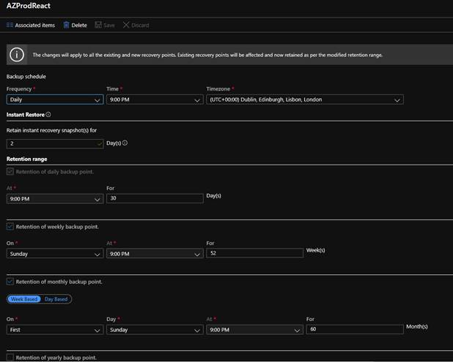

## Application Redeployment

### Requirements

You must prepare all the files for the deployment process and put them in working directory.

All necessary files for the redeployment are listed below:

* httpd.conf;
* deploy.bash;
* all configuration files;
* vasecurity.war;
* adminui.war;
* vahub.war.

**Note**: Look for configuration files at link. Copy entire folder 'react-config', verify path in react-configs\${env}\${customer}\var\vasecurity\vasecurity.conf.

### Credentials

Typically, there are three virtual machines for each environment: the management machine, the application server, and the database server. You manage the application server and the database server mainly through the management machine.

You will need the following information:

* Credentials for accessing virtual machines;
* Internal IP address to access the database;
* Internal IP address and credentials to access the application server.

### Redeployment Process

Follow the step-by-step instructions in this section to redeploy applications.

Download build artifacts (*.war or *.jar files) for VA-Security, AdminUI and VA-Hub from Jenkins, and get react-flyway.jar artifact from local folder react-flyway/target.

1. Connect to the environment via RDP. You should get Azure JIT access to the required environment.
2. Copy artifacts to the environment (via remote desktop) using Ctrl+C/Ctrl+V.
3. On the environment put react-flyway.jar into \conf folder of FlyWay installation directory (via remote desktop).
4. Connect to the application server via PuTTY (still from the remote desktop), using

[username]:${...AppServerPass from [AzureKeyVault](https://portal.azure.com/#@apps.idecide.science/resource/subscriptions/3fb8227d-79d9-454d-bd83-694876914794/resourceGroups/DECMT_SSLCERT/providers/Microsoft.KeyVault/vaults/DECMTkeyvault/secrets)}@10.0.1.4.

1. Stop all three applications:

sudo service ${serviceName} stop

1. Run flyway info, flyway migrate from the root of flyway installation folder. Be careful, 'flyway migrate' changes cannot be rolled back.
2. Using WinSCP, connect to [username]: ${...AppServerPass from [AzureKeyVault}@10.0.1.4](https://portal.azure.com/#@apps.idecide.science/resource/subscriptions/3fb8227d-79d9-454d-bd83-694876914794/resourceGroups/DECMT_SSLCERT/providers/Microsoft.KeyVault/vaults/DECMTkeyvault/secrets), update config files, changed from last deploy (check by change date). Replace as text (!do not just replace files!) contents of *.conf files with contents of conf files from react-configs project for the corresponding environment:

* /var/vasecurity/vasecurity.conf
* /var/adminui/adminui.conf
* /var/vahub/vahub.conf

1. Update *.yml files the same way. Configs are stored in the /home/[user]/react-configs folder.
2. Copy artifacts for VA-Security, AdminUI and VA-Hub to the /home/[user] folder via WinSCP.
3. Check date on environment and database servers (use Linux “date” command). If time is not in GMT, execute the following commands:

sudo unlink /etc/localtime

sudo ln -s /usr/share/zoneinfo/Etc/GMT-0 /etc/localtime

If you reset date on a database server, then server or database restart is required to apply the changes.

**Note**: Stop all services before restarting, and confirm restart with everyone who can be affected. See Database Restart section for additional information.

1. Clean kryoStorage and cacheStorage folders (they are located under system user root). Execute sudo -i and then rm -rf kryoStorage and rm -rf cacheStorage.
2. Truncate all filter tables (related to SQL-approach). All the tables with name like FILTER_[entity] and FILTER_[entity]_PKS (e.g. FILTER_AES, FILTER_AES_PKS) need to be truncated. Use DBLogin and DBPass credentials from [AzureKeyVault](https://portal.azure.com/#@apps.idecide.science/resource/subscriptions/3fb8227d-79d9-454d-bd83-694876914794/resourceGroups/DECMT_SSLCERT/providers/Microsoft.KeyVault/vaults/DECMTkeyvault/secrets). See Truncating filter tables (FILTER_*, FILTER_*_PKS) section for additional information.
3. Remove mapdb and hash files:

sudo rm /tmp/hash**\***, sudo rm /tmp/mapdb**\***.

1. Deploy artifacts one by one. Run commands in PuTTY from [username] home:

sudo sh deploy.bash vasecurity ${vasecurity artifact name}

**Wait** until deploy finishes, and check that the application is up:

/var/log/vasecurity/vasecurity.log.

**Note**: AdminUI and VA-Hub depend on it and will not start without it.

sudo sh deploy.bash adminui ${adminui artifact name}

sudo sh deploy.bash vahub ${vahub artifact name}

To verify that application started see logs:

less /var/log/vahub/vahub.log.

**Note**: Use G to navigate to the end of log.

1. Check space in the database server

**less /u01/app/oracle/diag/rdbms/react/react/trace/alert_react.log**.

If there are any issues with disk space, then the space should be cleaned up.

## Logging

Log files for applications can be found at:

* VA Security: /var/log/vasecurity/vasecurity.log;
* VA-Hub: /var/log/vahub/vahub.log;
* AdminUI: /var/log/admin/adminui.log.

You can use the following commands to read logs:

less /var/log/adminui/adminui.log

or

tail -f /var/log/adminui/adminui.log

Note: Pressing F inside less emulates “tail –f”.

or

vi /var/log/adminui/adminui.log

Note: Useful commands for navigation in less are provided at <https://www.thegeekstuff.com/2010/02/unix-less-command-10-tips-for-effective-navigation/>

## Applications Restart

Use the following commands to start/stop/restart applications:

sudo service <application name> start

sudo service <application name> stop

sudo service <application name> restart

Example:

sudo service vahub start

**Note**: Keep in mind that we have to follow the steps:

1. Start VA-Security at first;
2. Wait until it starts;
3. Start AdminUI;
4. Wait until it starts;
5. Start VA-Hub.

## Database Restart

In order to restart the database, connect it via ssh and run the following commands:

sudo su - oracle

sqlplus localhost:1521/react as sysdba

shutdown abort;

startup;

shutdown immediate;

startup;

exit;

lsnrctl stop

lsnrctl start

## Apply Database Changes (Flyway)

Flyway tool (<https://flywaydb.org/>) is used when upgrading the database (during release deployment). In accordance with the tool guideline, scripts are run in a certain order. It allows to keep the consistent state of the database.

## Apply Certificates

In order to apply new certificates for your domain names, the first thing you should do is to issue them.

Then perform the following actions to apply certificates:

1. Take two files for new certificate:

* cert.pem (or cert.pfx);
* key.pem (or key.pfx).

1. Upload these files to the environment to the user's working directory (e.g. /home/myuser/).
2. Open the folder containing the certificates files (user's working directory) on the server.
3. Convert the files to .crt and .key files using “openssl” command in cmd:

* for *.pem:

cert.pem -> ca.crt use command: 'openssl x509 -outform der -in cert.pem -out ca.crt'

key.pem -> ca.key use command: 'openssl rsa -outform der -in key.pem -out ca.key'

* for *.pfx:

openssl pkcs12 -in [name_of_the_file].pfx -clcerts -nokeys -out ca.crt

openssl pkcs12 -in [name_of_the_file].pfx -nocerts -nodes -out ca.key

Note: you need password to extract key and certification files from *.pfx.

1. Move these files to the appropriate folders on the server and restart httpd server:

$ sudo cp *folder_with_certs*/ca.crt /etc/pki/tls/certs/

$ sudo cp *folder_with_certs*/ca.key /etc/pki/tls/private/

$ sudo service httpd restart

1. If the DNS name is required, change the '*RedirectUri' fileds' to the required state in the 'vasecurity-azure-sso.yml' config file on the server. Do not forget to push these changes to the react-configs repository as well.

**Note**: It is useful to check that now you have renewed certificates for your application(s):

* Open application in a web browser;
* Click the field, which is on the left-hand side from the URL;
* Click 'Certificate' and check that now your application uses new certificate.

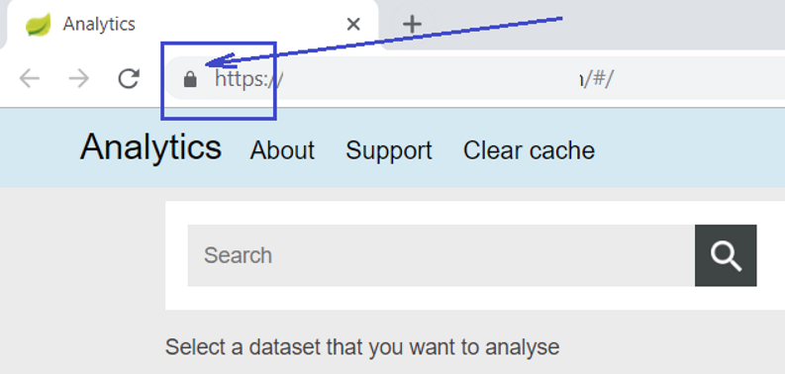

# Troubleshooting

## Redeployment: Issue with -Xmx -Xms Parameters

Sometimes when you replace .conf files for applications, a problem with parsing -Xmx and -Xms parameters could occur and application would not be started.

Steps to fix the problem:

1. Open the .conf file, which could not be parsed correctly.
2. Insert into this file full text of the appropriate .conf file.
3. Save the .conf file.
4. Start the appropriate service (adminui, vahub, vasecurity).

## Other Frequent Issues

### Whitelabel Error Page

Make sure that your account assigned in Azure Admin to the application you are opening.

### Connection Issue When Getting to a Jumpbox via RDP

Request JIT-access to 3389 port for your gate IP (virtual machine name ends with '%PNEMAN01', for instance 'DECMTPNEMAN01').

### Connection Issue When Getting via SSH to a Server in Azure Cloud

Request JIT-access to 22 port for the jumpbox machine IP you are trying to access from.

### Connection Issue When Getting to the Database in Azure Cloud

Request JIT-access to 1521 port for IP you have (e.g. jumpbox machine IP).

### Applications Cannot Connect to the Database

Make sure that there is a free disk space on server with database.

### Database ID is not Available

Make sure that listeners are up. If listeners are down, then start them: run lsnrctl start under oracle user on database machine. If you get ORA-01034 during starting listeners, then make sure that Oracle server is up. If it is not, then start it up:

$ORACLE_SID=react

$export ORACLE_SID

sqlplus localhost:1521/react as sysdba

SQL> startup

### Unstable Connection to Oracle Database and Errors in '/u01/app/oracle/diag/rdbms/react/react/trace/alert_react.log'

'Thread 1 cannot allocate new log, sequence 11920

Checkpoint not complete'

Most likely the reason is that the redo-log files are over and their size should be increased.

1. Building Docker Images

VA-HUB IMAGE

Create a Dockerfile with the following commands:

FROM openjdk:8-jdk-alpine

EXPOSE 8000

#you can download this war archive from Jenkins build directory

#and set directory with war as first argument of command below

COPY "/boot/target/vahub-5.0-SNAPSHOT.war" "vahub.war"

# set ip of database in application-docker.yml

# if you have containerized database, you can use name of the container or service (which you define in docker-compose file below)

# in our case it's just 'database' instead of regular ip

COPY "/local-configs/" "/local-configs/"

ENTRYPOINT java -Dspring.profiles.active=docker,local-no-security,NoScheduledJobs -Dspring.config.location=/local-configs/ -Dserver.port=8000 -Xms4096m -Xmx4096m -XX:MaxMetaspaceSize=1024m -Xmn1792m -XX:SurvivorRatio=8 -XX:+UseConcMarkSweepGC -XX:+CMSParallelRemarkEnabled -XX:+UseCMSInitiatingOccupancyOnly -XX:CMSInitiatingOccupancyFraction=70 -XX:+ScavengeBeforeFullGC -XX:+CMSScavengeBeforeRemark -XX:+PrintGCDateStamps -verbose:gc -XX:+PrintGCDetails -Xloggc:/ -XX:+UseGCLogFileRotation -XX:NumberOfGCLogFiles=10 -XX:GCLogFileSize=100m -XX:+HeapDumpOnOutOfMemoryError -XX:HeapDumpPath=/home/decmtreactadmin/oom_dumps/vahub_oom.hprof -XX:+UseStringCache -XX:+OptimizeStringConcat -jar vahub.war

Run this file from acuity root folder:

docker build -t vahub_local -f Dockerfile .

ADMINUI IMAGE

Create a Dockerfile with the following commands:

FROM openjdk:8-jdk-alpine

EXPOSE 9090

COPY "adminui-5.0-SNAPSHOT.war" "adminui.war"

# set ip of database in application-docker.yml

# if you have separate database container, you can use name of the container or service, which you define in docker-compose file

# in our case it's just 'database'

COPY "application-dev.yml" "/local-configs/application.yml"

# docker has shell and execution mode of bash commands

# acuity starts successfully only via shell mode(haven't found out why)

ENTRYPOINT java -Dspring.profiles.active=docker,local-no-security,azure-storage -Dserver.port=9090 -Dspring.config.location=/local-configs/ -server -Xms4096m -Xmx4096m -XX:MaxMetaspaceSize=1024m -Xmn1792m -XX:SurvivorRatio=8 -XX:+UseConcMarkSweepGC -XX:+CMSParallelRemarkEnabled -XX:+UseCMSInitiatingOccupancyOnly -XX:CMSInitiatingOccupancyFraction=70 -XX:+ScavengeBeforeFullGC -XX:+CMSScavengeBeforeRemark -verbose:gc -XX:+OptimizeStringConcat -jar adminui.war

Run this file from acuity root folder:

docker build -t admin_local -f Dockerfile .

1. ‘Kitematic’ - Graphical Interface for Docker

It can be also useful to load graphical interface for Docker, named ‘Kitematic’.

1. Open Docker context menu from the taskbar and select **Kitematic** item.

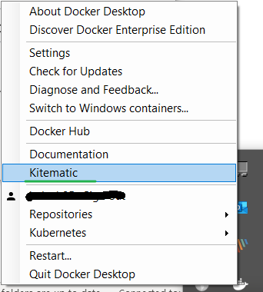

1. Download archive with Kitematic, install it and run.

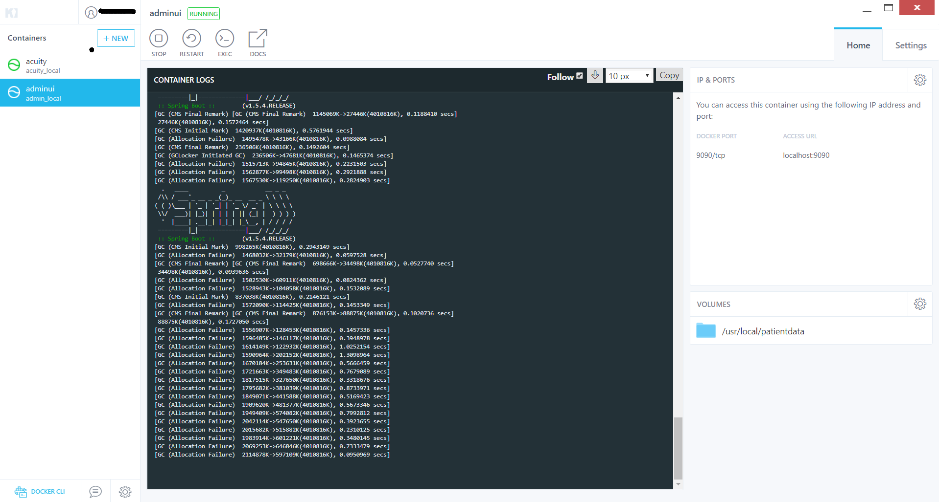

1. Click **Start** button to run Va-Hub and AdminUI.
2. Truncating filter tables (FILTER_*, FILTER_*_PKS)

Filter tables came from legacy SQL-approach. Sometimes (e.g. during a release process) they must be cleaned up. 'Delete from' is used instead of 'truncate' for some tables.

To truncate filter tables execute following queries:

TRUNCATE TABLE FILTER_AES;

TRUNCATE TABLE FILTER_AES_PKS;

TRUNCATE TABLE FILTER_ALCOHOL;

TRUNCATE TABLE FILTER_ALCOHOL_PKS;

TRUNCATE TABLE FILTER_CONMEDS;

TRUNCATE TABLE FILTER_CONMEDS_PKS;

TRUNCATE TABLE FILTER_DEATH;

TRUNCATE TABLE FILTER_DEATH_PKS;

DELETE FROM FILTER_DOSE;

TRUNCATE TABLE FILTER_DOSEDISC;

TRUNCATE TABLE FILTER_DOSEDISC_PKS;

TRUNCATE TABLE FILTER_DOSE_PKS;

DELETE FROM FILTER_EXACERBATION;

TRUNCATE TABLE FILTER_EXACERBATION_PKS;

DELETE FROM FILTER_HCE;

TRUNCATE TABLE FILTER_HCE_PKS;

TRUNCATE TABLE FILTER_LABS;

TRUNCATE TABLE FILTER_LABS_PKS;

TRUNCATE TABLE FILTER_LIVER;

TRUNCATE TABLE FILTER_LIVER_DIAG;

TRUNCATE TABLE FILTER_LIVER_DIAG_PKS;

TRUNCATE TABLE FILTER_LIVER_PKS;

TRUNCATE TABLE FILTER_LIVER_RISK;

TRUNCATE TABLE FILTER_LIVER_RISK_PKS;

DELETE FROM FILTER_LUNGFUNCTION;

TRUNCATE TABLE FILTER_LUNGFUNCTION_PKS;

TRUNCATE TABLE FILTER_LVEF;

TRUNCATE TABLE FILTER_LVEF_PKS;

TRUNCATE TABLE FILTER_MH;

TRUNCATE TABLE FILTER_MH_PKS;

TRUNCATE TABLE FILTER_NICOTINE;

TRUNCATE TABLE FILTER_NICOTINE_PKS;

TRUNCATE TABLE FILTER_POPULATION;

TRUNCATE TABLE FILTER_POPULATION_PKS;

TRUNCATE TABLE FILTER_QTCF;

TRUNCATE TABLE FILTER_QTCF_PKS;

DELETE FROM FILTER_RECIST;

TRUNCATE TABLE FILTER_RECIST_PKS;

TRUNCATE TABLE FILTER_RENAL;

TRUNCATE TABLE FILTER_RENAL_PKS;

TRUNCATE TABLE FILTER_SAE;

TRUNCATE TABLE FILTER_SAE_PKS;

TRUNCATE TABLE FILTER_SAFETY_POPULATION;

TRUNCATE TABLE FILTER_SAFETY_POPULATION_PKS;

TRUNCATE TABLE FILTER_SH;

TRUNCATE TABLE FILTER_SH_PKS;

TRUNCATE TABLE FILTER_VITALS;

TRUNCATE TABLE FILTER_VITALS_PKS;

1. Maintaining the Database (Dumps, Creation, Deletion)

**Note: All underlined words represent dump names. In your particular case, these names could be different, so your attention is required here. Words in *italics* are used for comments.**

Find the required paragraph and follow step-by-step instructions to achieve your purpose.

DATABASE DELETION

sudo su - oracle -c 'dbca -silent -deleteDatabase -sourceDB react'

DATABASE CREATION

1. sudo su - oracle -c 'export ORACLE_HOME=/u01/app/oracle/product/18.0.0/dbhome_1'
2. sudo su - oracle -c 'export PATH=$ORACLE_HOME/bin:$PATH'
3. sudo su - oracle -c 'dbca -silent -createDatabase -templateName General_Purpose.dbc -gdbname react -sid react -responseFile NO_VALUE -characterSet AL32UTF8 -sysPassword OraPasswd1 -systemPassword OraPasswd1 -createAsContainerDatabase true -numberOfPDBs 1 -pdbName pdb1 -pdbAdminPassword OraPasswd1 -databaseType MULTIPURPOSE -automaticMemoryManagement false -ignorePreReqs'
4. sudo su - oracle -c "echo 'export ORACLE_SID=react'>>/home/oracle/.bashrc"
5. sudo su - oracle -c 'lsnrctl stop'
6. sudo su - oracle -c 'lsnrctl start'

PREPARING DATABASE TO WORK (CREATING TABLESPACES, GRANTING RIGHTS, SET PROCESSES, ETC.)

1. sudo su - oracle
2. sqlplus / as sysdba
3. create tablespace react_ts datafile 'react_ts.dbf' size 4g reuse autoextend on;
4. alter session set "_ORACLE_SCRIPT"=true;
5. create user reactdev identified by "reactdev_pass!" temporary tablespace temp default tablespace react_ts quota unlimited on react_ts quota 1000m on system; – *change the password to the appropriate one*
6. grant create session to reactdev;
7. grant create table to reactdev;
8. grant create view to reactdev;
9. grant create trigger to reactdev;
10. grant create any procedure to reactdev;
11. grant create sequence to reactdev;
12. grant create synonym to reactdev;
13. create or replace directory dumpdir as '/u01/app/oracle/product/18.0.0/dbhome_1/';
14. grant read, write on directory dumpdir to reactdev;
15. alter system set processes=500 scope=spfile;
16. shutdown abort;
17. startup;
18. shutdown immediate;
19. startup;
20. show parameter processes;
21. quit
22. exit

DUMP CREATION

1. sudo su - oracle
2. rm -rf dump
3. mkdir dump
4. sqlplus localhsot:1521/react as sysdba
5. Grant create any directory to reactdev;
6. exit
7. sqlplus – do it with reactdev
8. create or replace directory mydump as '/home/oracle/dump';
9. exit
10. expdp reactdev/'reactdev_pass'@localhost:1521/react directory=mydump dumpfile=reactdmp.dmp  – change the password to the appropriate one
11. exit
12. sudo mv /home/oracle/dump/reactdmp.dmp /home/commander/
13. sudo chmod 777 /home/commander/reactdmp.dmp

DUMP IMPORT

1. sudo cp reactdmp.dmp /u01/app/oracle/product/18.0.0/dbhome_1/
2. sudo su - oracle -c 'impdp reactdev/'reactdev_pass!'@localhost:1521/react directory=dumpdir dumpfile=reactdmp.dmp partition_options=merge'
3. change the password to the appropriate one;
4. *dumpdir* is an alias for the directory */u01/app/oracle/product/18.0.0/dbhome_1/*, see 4.13;
5. if reactdmp.dmp was created from another schema and tablespace, provide additional options for *impdp* command: *remap_schema=old_schema:reactdev remap_tablespace=old_tablespace:react_ts*.
6. sudo su - oracle -c 'lsnrctl stop'
7. sudo su - oracle -c 'lsnrctl start'
8. Make sure your dump has all FlyWay migrations, corresponding to the current code version.