Cancer Trial Finder Template

Philip Russell
June 2021

Contents
1 Cancer Trial Finder Template 1
1.1 The Template 1
1.2 Request a Copy of the Template 2
2 General Information Regarding Google Forms 4
2.1 Sections 4
2.2 Subsections 4
2.3 Description 5
2.4 Linking 6
2.4.1 To Another Section 6
2.4.2 To Submit Form 7
2.5 Previewing the Trial Finder 8
2.6 Undoing changes 8
2.7 Styling the Trial Finder 8
3 Creating Your Own Cancer Trial Finder 9
4 Section Categories 10
4.1 Category 1: Landing Page 10
4.1.1 Description 10
4.1.2 Create Your Version of the Landing Page 11
4.1.3 Moving to the Next Section 13
4.2 Category 2: Options 14
4.2.1 Description 14
4.2.2 Create Your Version of Options 15
4.2.3 Moving to the Next Section 16
4.2.4 Making a Section Required 16
4.3 Category 3: Single Study 17
4.3.1 Description 17
4.3.2 Create Your Version of a Single Study Section 18
4.4 Category 4: Multiple Studies 19
4.4.1 Description 19
4.4.2 Create Your Version of a Multiple Studies Section 20
4.5 Category 5: No Suitable Study 21
4.5.1 Description 21
4.5.2 Create Your Version of No Suitable Study Section 21
4.6 Category 6: Portfolio 22
4.6.1 Description 22
4.6.2 Create Your Version of Portfolio 24
5 Sharing the Trial Finder 27
6 Metrics 28

Cancer Trial Finder Template
The cancer trial finder template can be used to create an online tool that displays clinical trial options. The aim of the tool is to raise awareness of recruiting trials by making the trial information accessible to clinicians and the wider multidisciplinary team from any location.
The template has been created by Philip Russell, a research nurse at The Christie NHS Foundation Trust, based on his Lung Cancer Trial Finder tool which was developed to meet a need to inform clinicians about trial options in the lung cancer population. The tool has been used successfully at The Christie for 4 years.
Using the template, you and your team can create a trial finder specific to your own research area. The tool will be owned by you and your team, and thus it is the team’s responsibility to keep the trials presented by the tool up to date.

The Template
The template has been developed using Google Forms and contains 30 sections which fall into six categories: landing page, options, single trial, trials, no trials, and portfolio (see Appendix 1). The trial finder is created by linking these sections to guide the user to the relevant trials based on their search criteria; the use of linking will be described later in this document.
The template is based on the workflow shown below. The user first enters the tool on the landing page. They then move through one or more screens of options before arriving at relevant trials if any are open and recruiting.
Landing Page
Options
Trials
The options presented to the user depend on how you want to group your trials; for example, in the Lung Cancer Trial Finder the trials have been grouped at the highest level by:
- the type of lung cancer: NSCLC or SCLC
- the relevance to teams: Experimental Cancer Medicine Team, Advanced Cell Therapy Team
- studies: PAN Disease Study, Biomarker/Observational Studies, Lung Study Portfolio
The pathways through the template are presented in the decision tree in Appendix 2. The template can be edited to create the trial finder which works best for your team. You may want to use the flow presented by the template or create your own. The following sections will guide you through this process.

Request a Copy of the Template
To receive a copy of the template, you need to have a Google account to access Google Forms. We advise creating a generic team account rather than using a personal account.
- Copy and paste docs.google.com/forms into your browser
- Click ‘Create account’ then Next. Follow the steps to create an account for the team (this will be a gmail account).
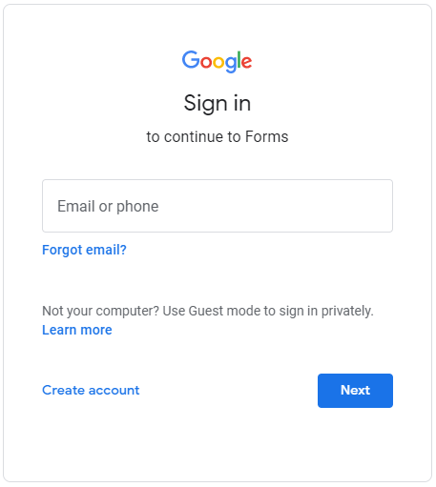

- You will be taken to Forms, which will not contain any Recent forms.
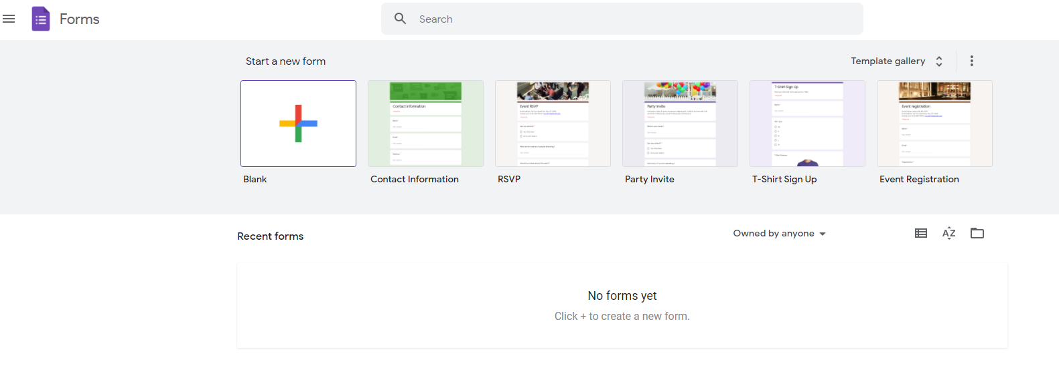

- To request a copy of the template, please email: the-christie.digitaltrialfinder@nhs.net with the generic team account details. Please use this address if you have any queries regarding the template.

- Once you have been given access to the template, log into docs.google.com/forms and the template will be present in Recent forms.

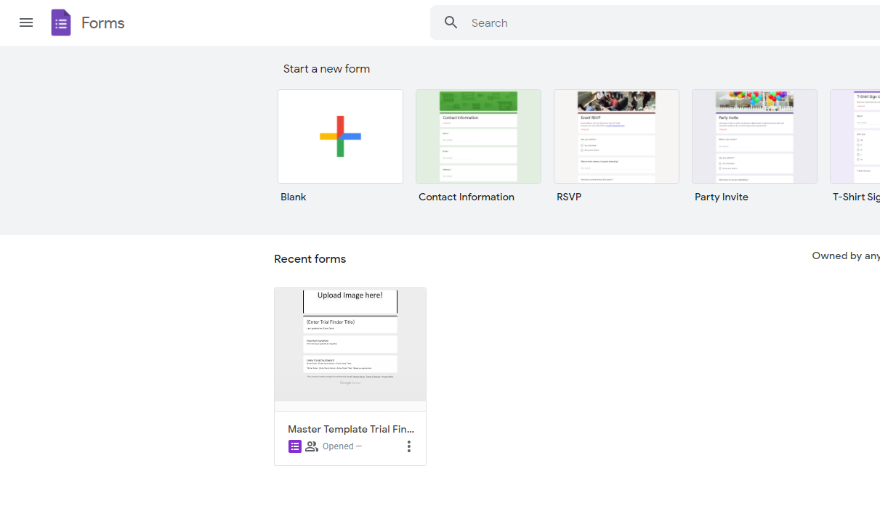

- To open the template
  - Click on it
  - or click on the three dots and ‘Open in new tab’.

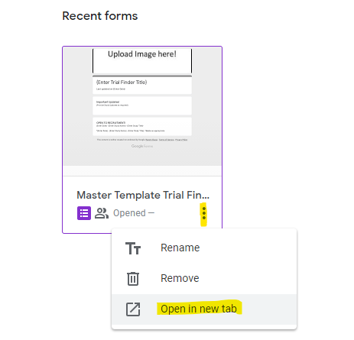

- You can now edit the template.

General Information Regarding Google Forms
Google Forms are composed of sections and sub-sections (referred to as boxes in this document) which can be duplicated or deleted. There is also a special ‘Submit Form’ section.

Sections
These form the main body of the template. To remove or duplicate them, click on the three dots at the top of a section to reveal the menu.
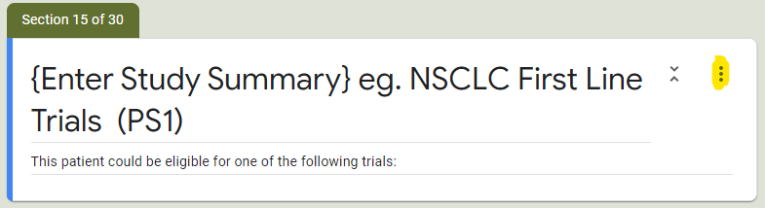 | 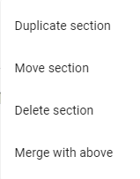

Subsections
These form the content of the section. To remove or duplicate them, click on the subsection and then the relevant icon, which may appear at the top or bottom of the subsection.
In the second image, you can see a ‘Required’ button. This is used when a section must be completed by a user before they can move to the next section. This will be described later in the document.

Description
If you click on the three dots in a subsection, you will see ‘Description’. Clicking on this allows text to be added.

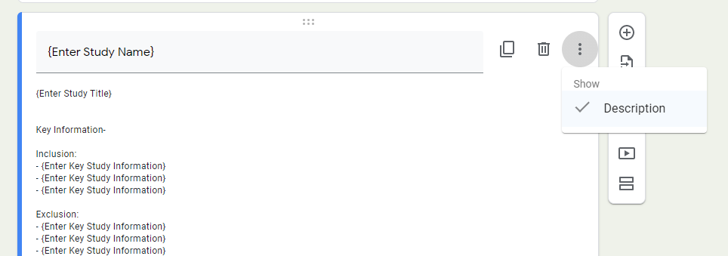

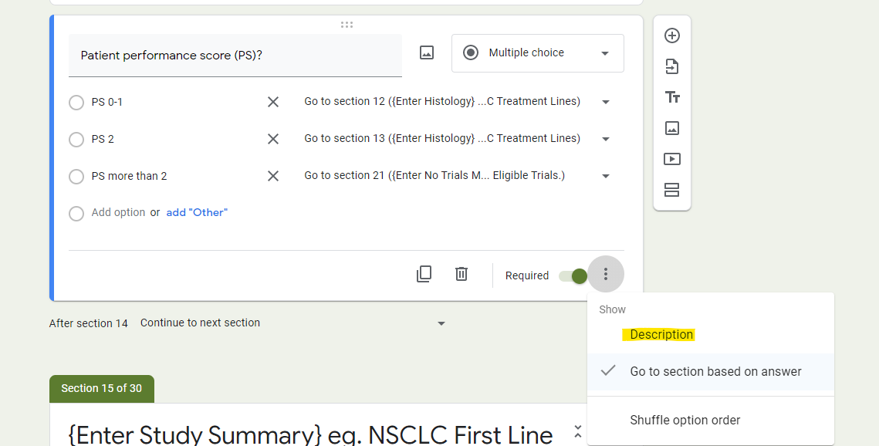

Linking

To Another Section
Linking sections provides the flow through the trial finder. There are two ways to link sections.
- Via the bottom of the section
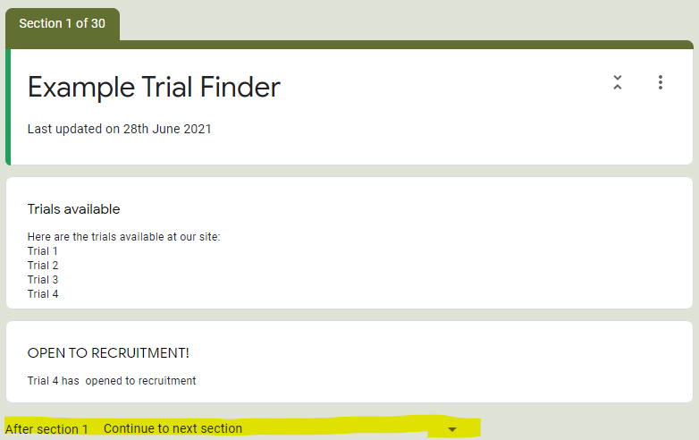

- The linking can be changed by clicking on the arrow to reveal a list of the sections in the template and ‘Submit Form’. Click on the section you want the trial finder to move to next.

- Within the subsection
- Click on the subsection. You will see ‘Go to section….’. Click on the arrow at the end of the row to see a list of all the sections and ‘Submit Form’ present in the template appears. Click on the section you want the trial finder to move to next.

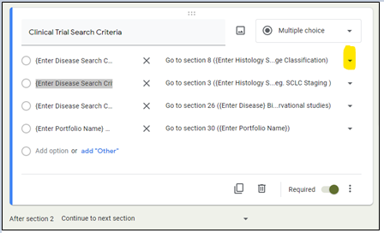
Note: you can link to the same section more than once.

To Submit Form
Linking to ‘Submit Form’ places a ‘Submit’ button on the screen. Clicking on ‘Submit’ takes the user to the last page in the trial finder, and metrics about their use of the trial finder are collected (see section 6).
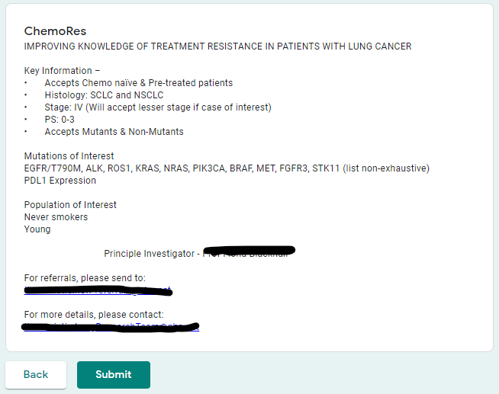
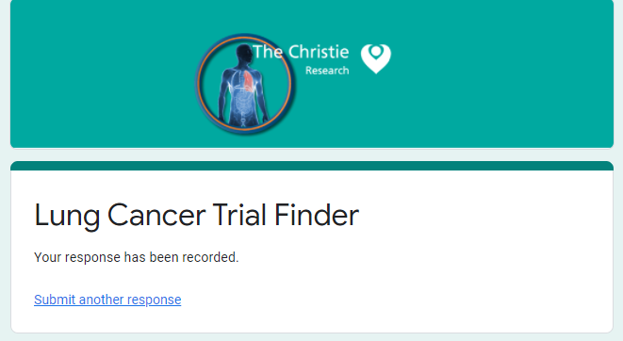
Clicking on the link ‘Submit another response’ takes the user back to the first page of the trial finder. The link cannot be edited but it can be hidden and the text above it (‘Your response has been recorded’) changed. To do this, click on the settings icon at the top right of the form then ‘Presentation’ in the window that opens.
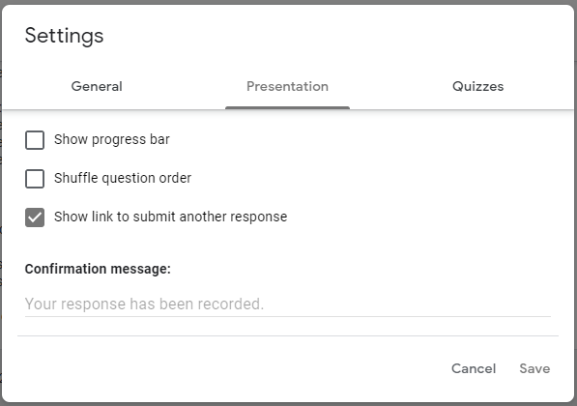
- To hide the link, uncheck the box ‘Show link to submit another response’.
- To change the text, type on the lines beneath ‘Confirmation message:’.
You do not need to link to Submit Form in your trial finder. You can link back to the landing page once the user has got to the end of a particular workflow through the tool.

Previewing the Trial Finder
Click on the eye icon at the top right to preview the trial finder, which will open in a new tab.

Undoing changes
If you make a change by mistake, press ‘Ctrl’ and ‘z’ to undo.

Styling the Trial Finder
You can change the colour and font of your application using Theme options which appear on clicking the paint palette in the top-right corner of the form.

Creating Your Own Cancer Trial Finder
The template can be edited to create the trial finder which works best for your team. You may want to use the flow presented by the template or create your own by changing/removing the links between sections; for example, you may want all the trials listed on the landing page in which case, the user does not need to navigate through any other sections.
The next part of the document describes the different types of sections present in the template and how they are edited.

Section Categories

Category 1: Landing Page

Description
The landing page can contain any information you want. Here are some examples of what you might want to include:
- When the trial finder was last updated
- Links to relevant websites such as Twitter
- Studies which have recently opened to recruitment
- Important Study Updates
This is what the landing page looks like in the Lung Cancer Trial Finder.
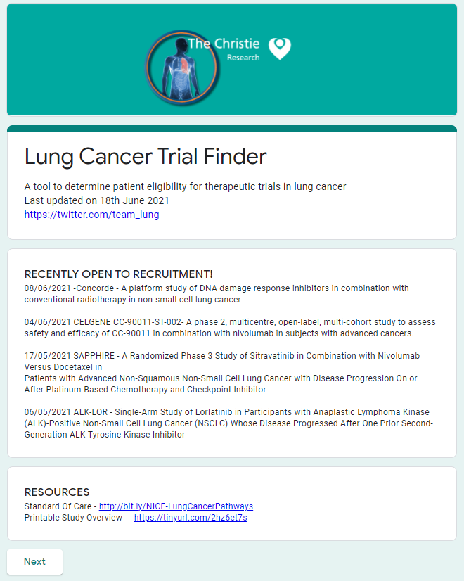

Create Your Version of the Landing Page
The landing page in the template is shown below and is section 1.
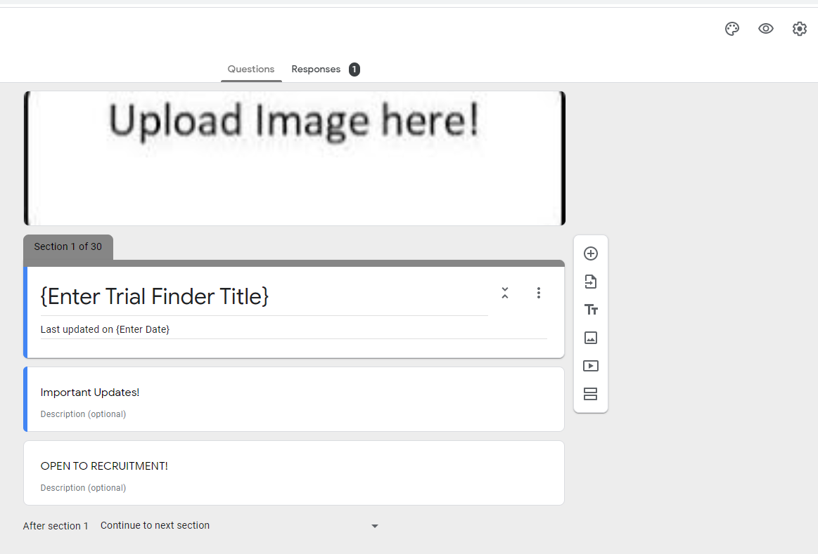

Add the image at the top
- Click on the paint palette in the top right corner to reveal ‘Theme options’
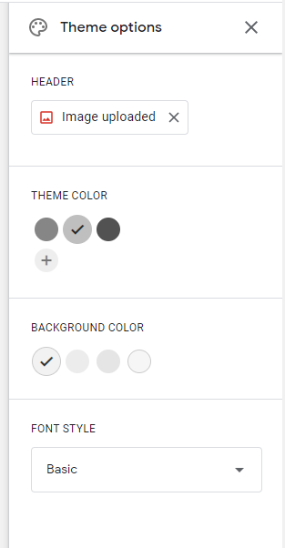

- Click on ‘Image uploaded’ to reveal ‘Select Header’. To use a specific image, click on ‘Upload’ and browse to your file.
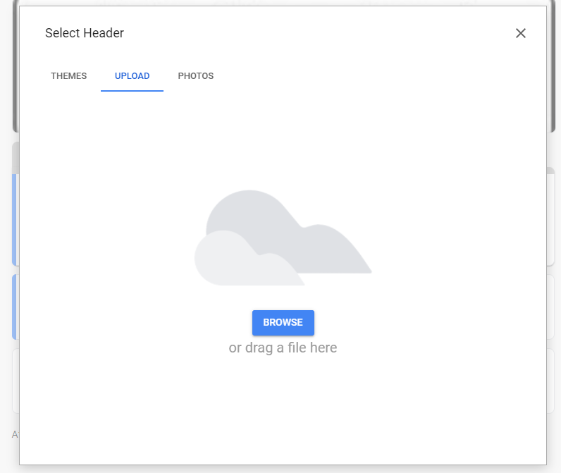
If you do not have an image you want to include, click on ‘Themes’ and select an image.
If you do not want to include a top section, do not upload anything – close ‘Select Header’ without selecting anything.

Update the text
- Click within the top box in the section. The text where you click in the box will be highlighted. Enter the text you want.
Here {Enter Trial Finder Title} is high-lighted.
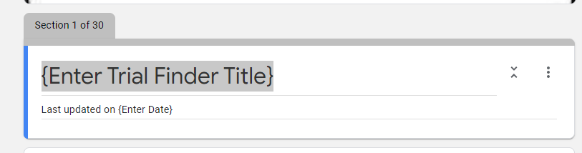
The text has been updated as shown below.
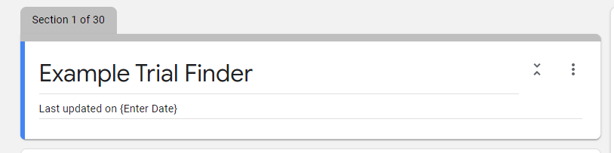
- Click on ‘Last updated on {Enter Date}, which becomes high-lighted for editing.
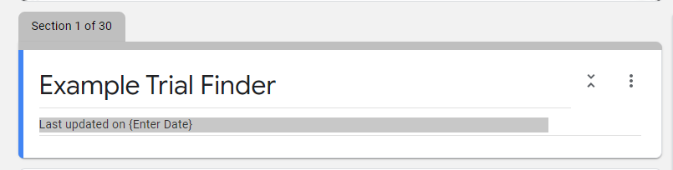
The text has been updated.
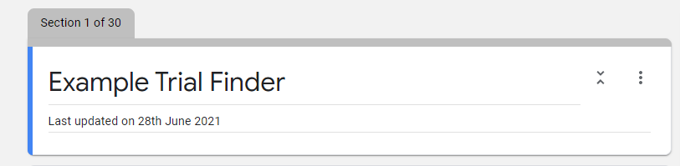

Preview Your Changes
When you have completed updating the section, you can preview it by clicking on the eye icon in the top-right hand corner. A preview of the form will appear in a new tab.
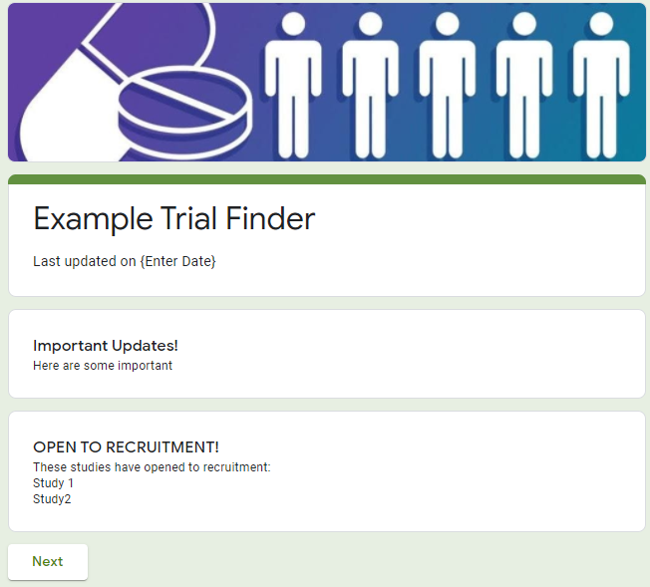

Moving to the Next Section
In the template, the user is taken from the landing page to section 2 in the template. This is our first example of linking sections. At the bottom of section 1 there is a statement which states ‘After section 1 Continue to next section’, i.e., section 2.
The linking can be changed by clicking on the arrow to reveal a list of the sections in the template and ‘Submit Form’ (see 2.4.2 ). Select the section you want the user to be taken to next.

Category 2: Options

Description
From the landing page, the user is taken to a page where they are presented with options related to ‘Clinical Trial Search Criteria.’ This is what it looks like in the Lung Cancer Trial Finder. The user must complete this page before they can move onto the next section. This is signified on the page by * Required.
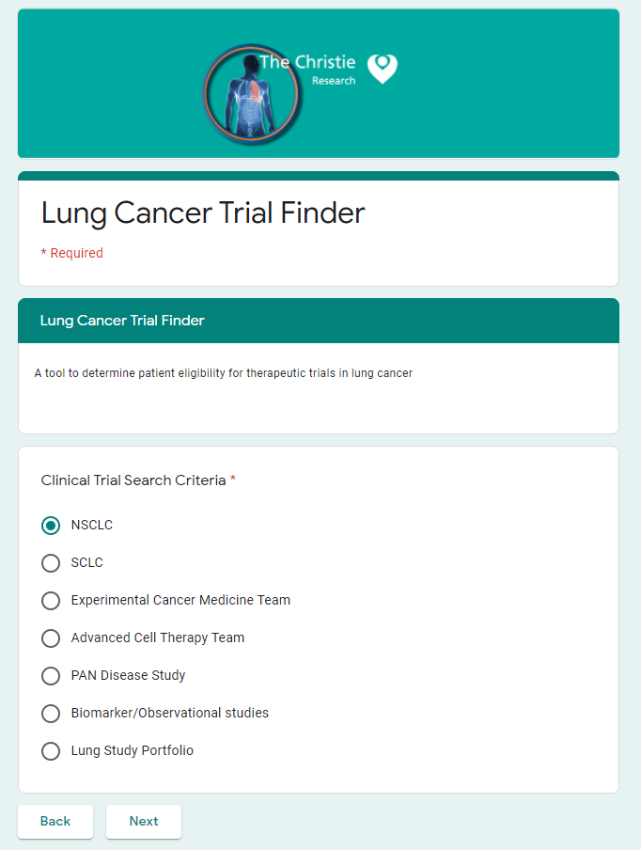

Create Your Version of Options
The first options section in the template is shown below and is named section 2.
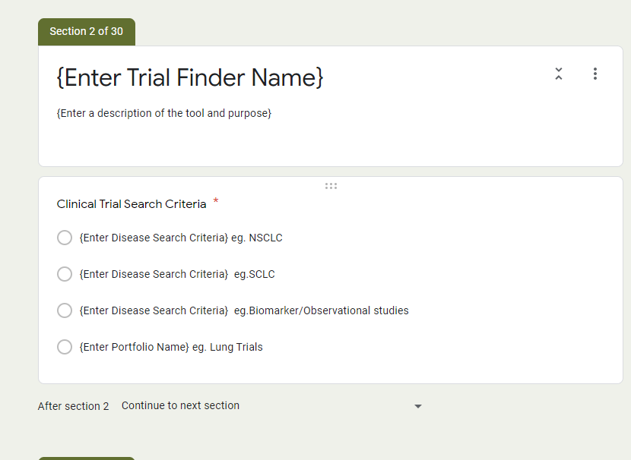
- Click on the top box to enter the trial finder name, and the description of the tool.
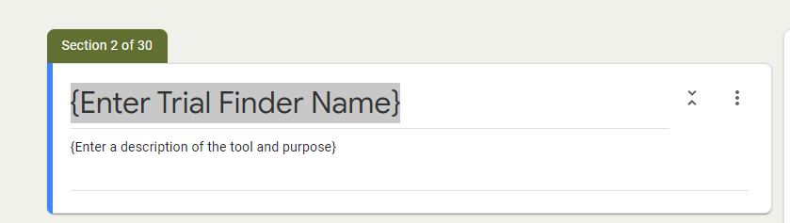
- Click on the bottom box to edit the options presented.
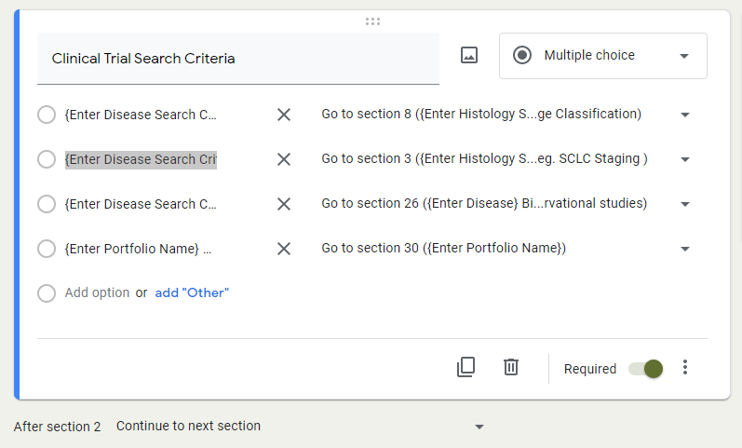
- To change ‘Clinical Search Criteria’, click on the text to edit it.
- To edit an option, click on the text next to the circle.
- To remove an option, click the X
- To add an option, click ‘Add option or add “Other”.

Moving to the Next Section
When an option is selected, you want the user to be taken to the appropriate section of the trial finder; this may be further options they need to choose from or the presentation of trials.
- Click on the arrow at the end of the row. A list of all the sections present in the template appears. Click on the section you want.
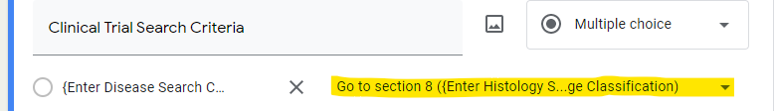

For this section, the following links are present in the template.
Option Number | Link | Category | Description of the section
1 | Section 8 | Options | NSCLC TNM Stage Classification
2 | Section 3 | Options | SCLC Staging
3 | Section 26 | Trials | Biomarker/Observational Studies
4 | Section 30 | Portfolio | Lung Study Portfolio

Making a Section Required
At the bottom of the section there is an on/off switch ‘Required’. If it is turned on, i.e., to the right, the user MUST select an option in this section before they can move to the next one.
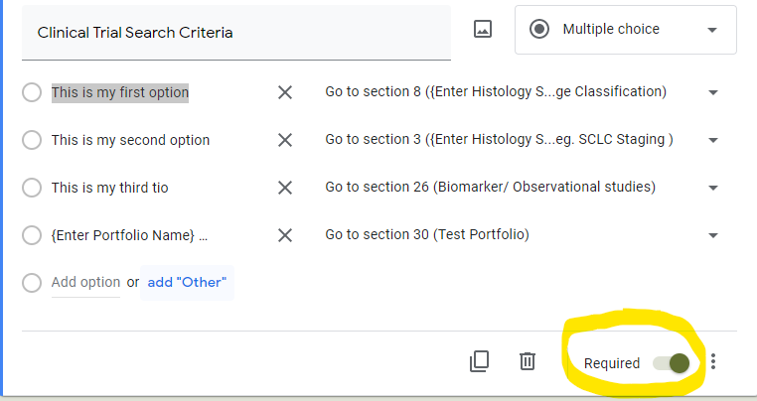

Category 3: Single Study

Description
This section contains details of a single study and can display information such as:
- Trial title
- Key Information – inclusion/exclusion criteria
- Principle Investigator
- Contact Details
Here is an example from the Lung Cancer Trial Finder.
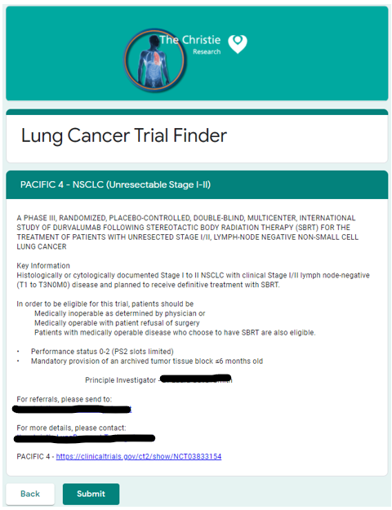

Create Your Version of a Single Study Section
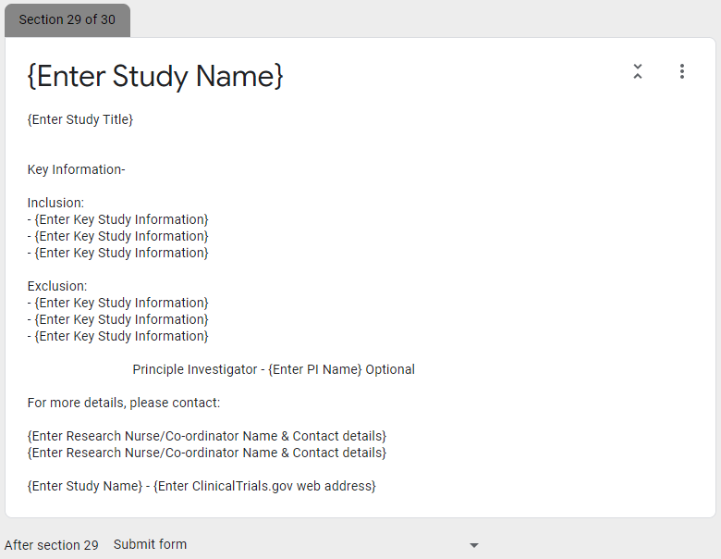
- As discussed earlier, click on the section to edit it.
- Text written in the form of a website is recognised as such and will present as a link on the page. When it is clicked, the website will open in a new tab.
- Text written in the form of an email address is recognised as such and will present as a link. When the link is clicked, the default email application opens with To: populated with the email address.

View in the Template | View in the Trial Finder
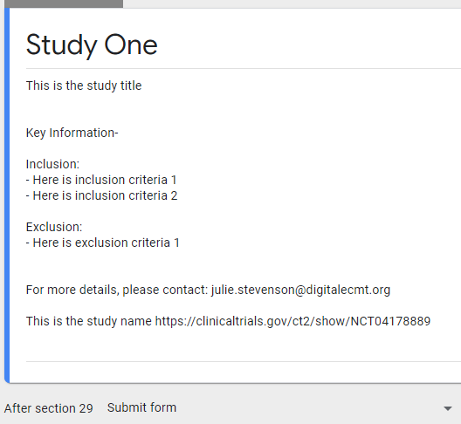 | 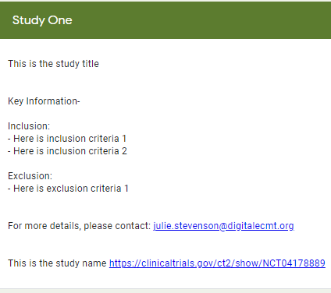

Category 4: Multiple Studies

Description
The Multiple Studies sections contain details of two or more trials and can display information such as:
- Trial title
- Key Information – inclusion/exclusion criteria
- Principle Investigator
- Contact Details
Here is an example from the Lung Cancer Trial Finder, which contains two trials.
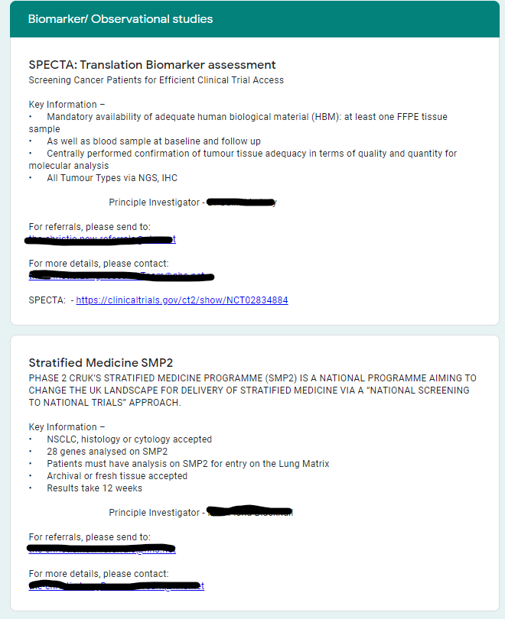

Create Your Version of a Multiple Studies Section
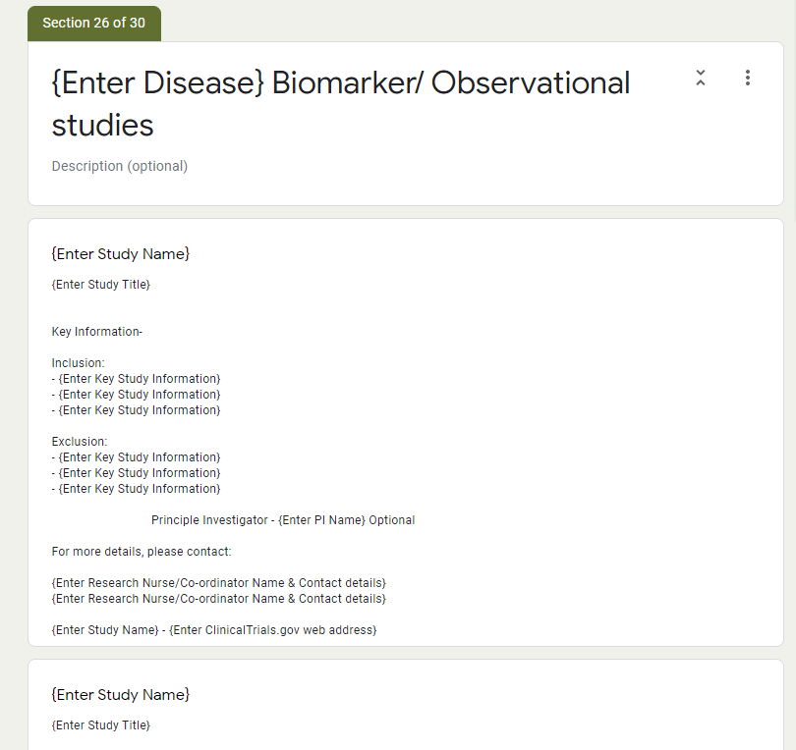
This is similar to creating a Single Study section as described in 4.3.

Category 5: No Suitable Study

Description
This section is used to inform the user that there are no suitable trials for the criteria they have selected. Here is an example from the Lung Cancer Trial Finder.
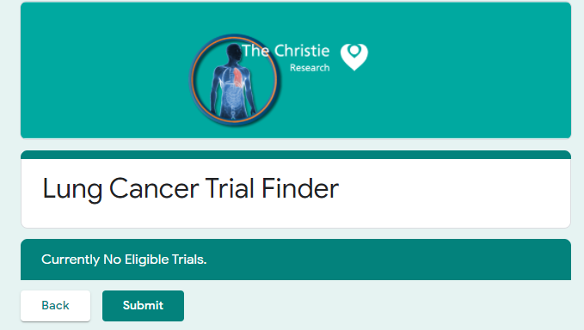

Create Your Version of No Suitable Study Section
This is found as section 21 in the template and is shown below.
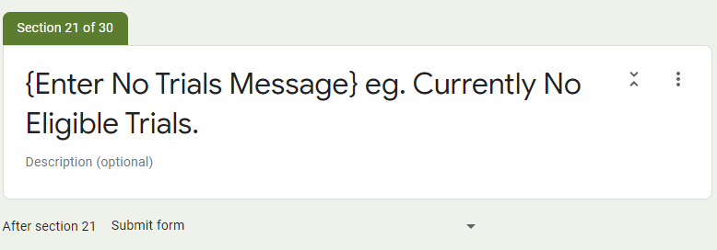
- To edit the message displayed, click on the section itself.
- To change the section the user is taken to next, click on the arrow at the bottom.

Category 6: Portfolio

Description
The Portfolio shows all the trials in a list. The user picks one to see the details. An example from the Lung Cancer Trial Finder is shown below.
- The user clicks on ‘Choose’
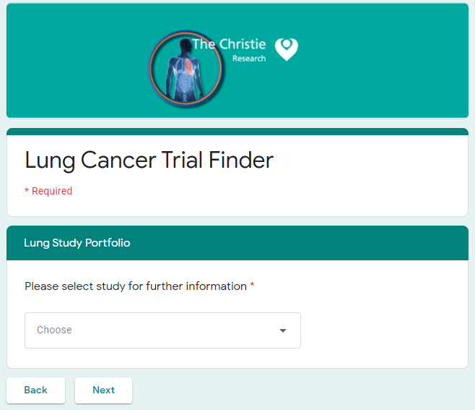
- The user clicks on a trial from the list displayed
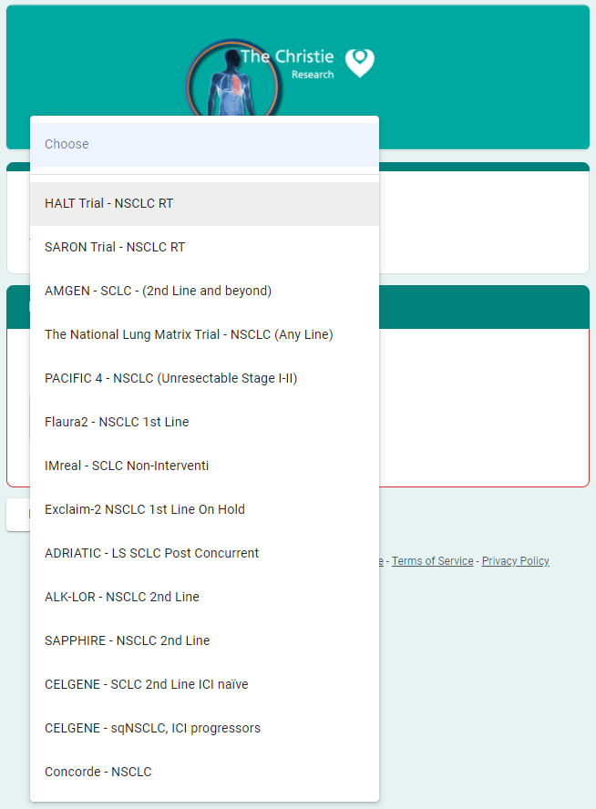
- The name of the trial is displayed. The user clicks on Next.
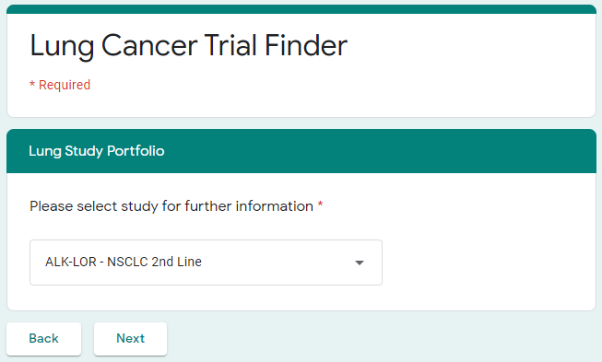

- The details of the trial are displayed.
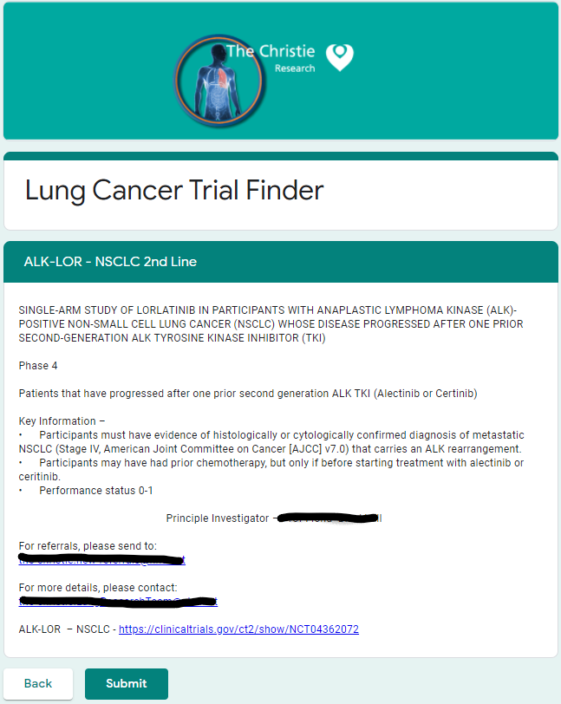

Create Your Version of Portfolio
This is section 30 in the template.
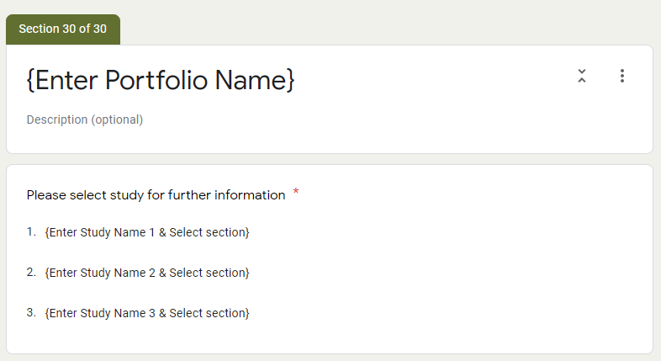
- Click on the top box to edit the name of the portfolio and provide a description if required.
- Click on the bottom box to show the following subsection. Here you can see the type is ‘Dropdown’ rather than multiple choice, i.e., a ‘dropdown’ list of studies is shown to the user.
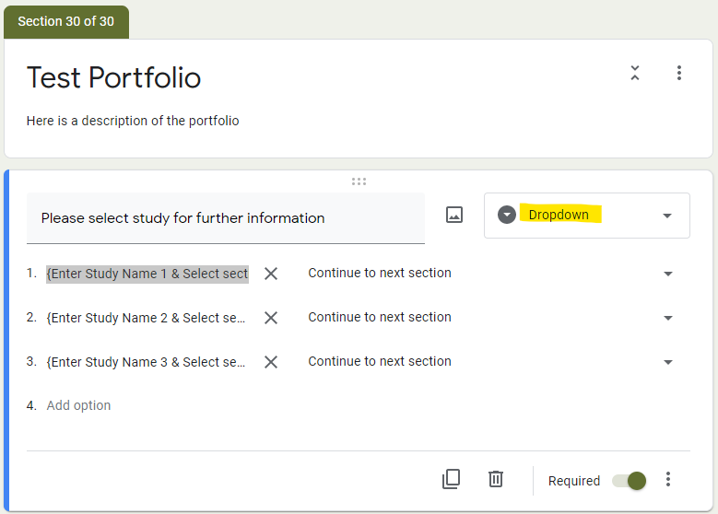
- To create the list, click on a row and it will become editable. Add the study name.
- To take the user to the selected study, click on the arrow at the end of the row. A list of all the sections present appears. Click on the one which relates to the study.
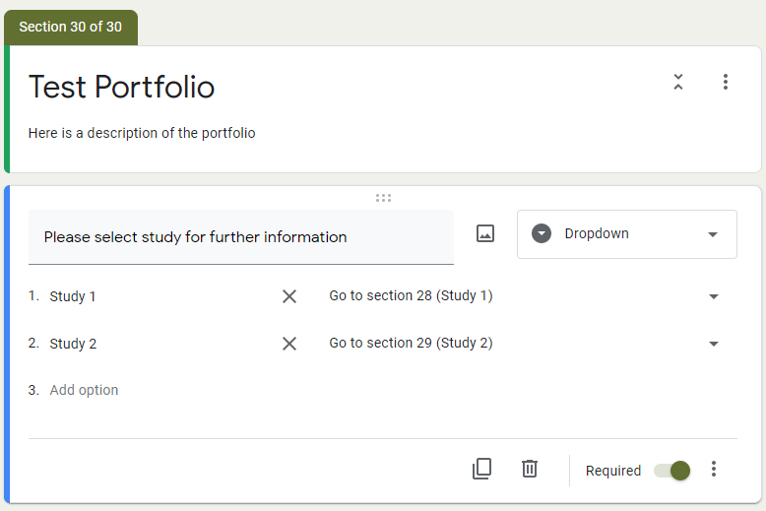
Below are the two single studies in the template which are in the portfolio.
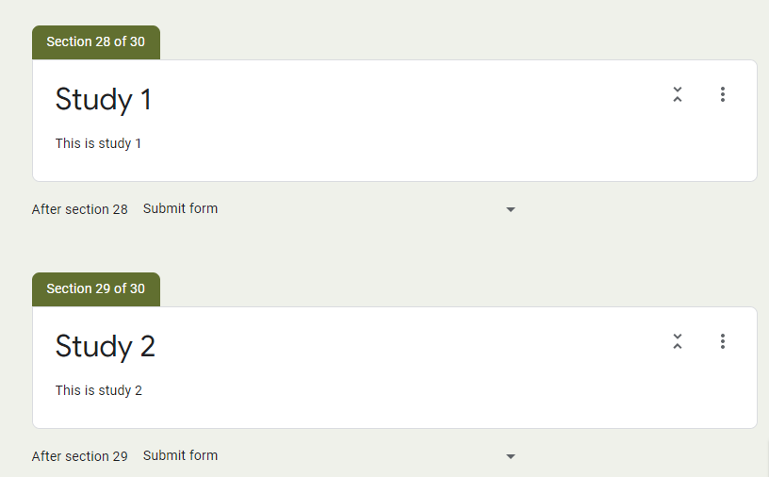
When click on preview, see the following –
- The Portfolio list comprising Study 1 and Study 2
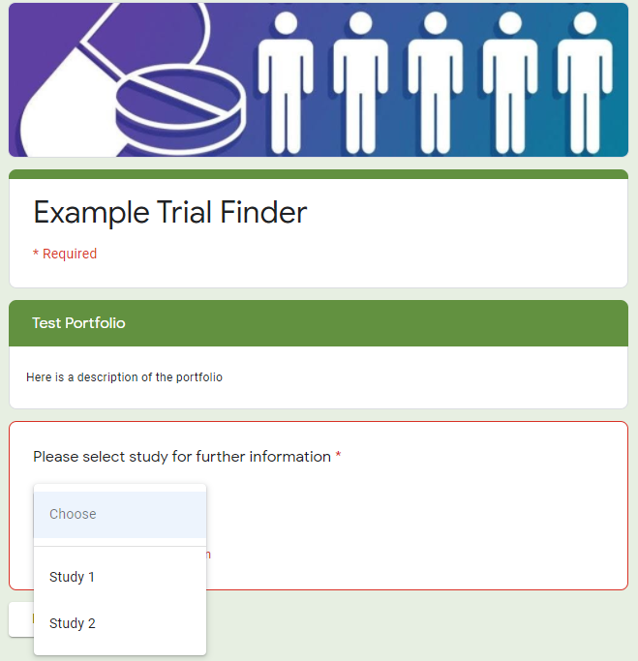
- When select Study 1 and click on Next, see Study 1.
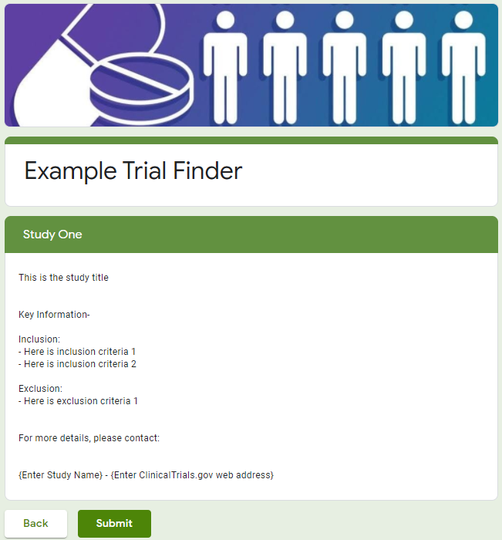

Sharing the Trial Finder
Once you have created your trial finder, you can share it with the team by clicking ‘Send’ in the top right corner.

In the window which appears, click on the chain to obtain a link for the trial finder. To shorten the link, tick the ‘Shorten URL’ box. You can then copy and share this link with the team.
If you want to change the link to something more user friendly, there is software freely available to do this, for example, https://bitly.com/
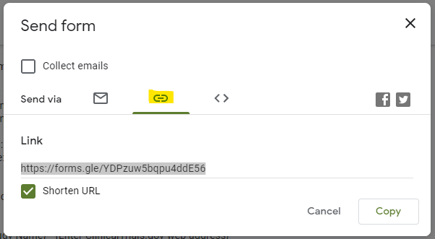

To prevent anyone you share the link with changing the trial finder, do not click on ‘Add Collaborators’, which is found on the tab beneath the envelope symbol.

Metrics
The metrics document how many ‘hits’ there were per section of your trial finder and will therefore help your team understand which trials are those most commonly looked for amongst your patient population.
To capture the metrics, the ‘Submit’ button must present at the end of each search and the user must click on it, as discussed in 2.4.2.
To view the metrics, click on ‘Responses’ at the top and you will see the breakdown of hits per section. In the example below, it can be seen that 5 people have used the trial finder and clicked ‘Submit. The most common clinical search criteria was Criteria 1.
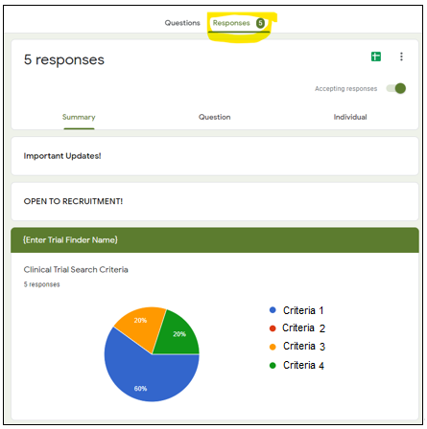

Appendix 1 – Section Categories
Section Number | Category | Description
 | Landing page | Homepage of the tool
 | Options | Clinical Trial Search Criteria
 | Options | Stage #1
 | Options | Performance score #1
 | Options | Clinical scenario #1
 | Options | Clinical scenario #2
 | Options | Performance score #2
 | Options | Stage #2
 | Options | Performance score #3
 | Options | Treatment for PS 0-1 #1
 | Options | Treatment for PS 2 #1
 | Options | Treatment for PS 0-1 #2
 | Options | Treatment for PS 2 #2
 | Options | Performance score #4
 | Trials | List of trials for first line PS1
 | Trials | List of trials for first line PS2
 | Trials | List of trials for second line PS1
 | Trials | List of trials for third line & beyond PS1
 | Trials | List of trials for second line PS2
 | Trials | List of trials for third line & beyond PS2
 | No trials | No trials available
 | SingleTrial | Sequential CRT Stage III
 | Trials | Extensive - First line
 | Trials | Extensive - Second line
 | Trials | Extensive – Third line & beyond
 | Trials | Biomarker/Observational Studies
 | No trials | Closed
 | Single Trial | Description of single trial
 | Single Trial | Description of single trial
 | Portfolio | List of trials

Appendix 2 – The Template Decision Tree

