Cancer Trial Finder Guidance

Philip Russell
June 2021

Contents
1 Cancer Trial Finder 1
2 Adding the trial finder to your browser’s “favourites” page 1
3 Adding the trial finder to your desktop on the computer. 2
4 Adding the trial finder to your mobile/tablet 3
4.1 Apple IOS 3
4.2 Android 3

Cancer Trial Finder
The cancer trial finder is an online tool that displays clinical trial options. The aim of the tool is to raise awareness of recruiting trials by making the trial information accessible to clinicians and the wider multidisciplinary team from any location.
The Lung Cancer Trial Finder was the first cancer trial finder and was created by Philip Russell, a research nurse at The Christie NHS Foundation Trust. It was developed to meet a need to inform clinicians about trial options in the lung cancer population. The tool has been used successfully at The Christie for 4 years.

Adding the trial finder to your browser’s “favourites” page
The examples below use Chrome.
- Open the link to the trial finder which has been shared with you in Chrome.

- Click on the star at the top.
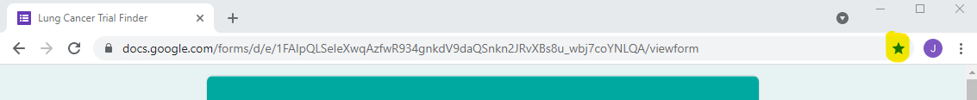

- Click ‘Add bookmark’.
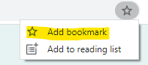

- Name the bookmark appropriately and click ‘Done’.
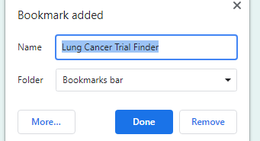

- The link appears on the menu bar. When you click on it the trial finder will open.
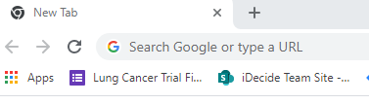

Adding the trial finder to your desktop on the computer.
The examples below use Chrome.
- Open the link to the trial finder which has been shared with you in Chrome.

- Click on the three dots at the top right.
- Click on ‘More tools’ then ‘Create shortcut…’
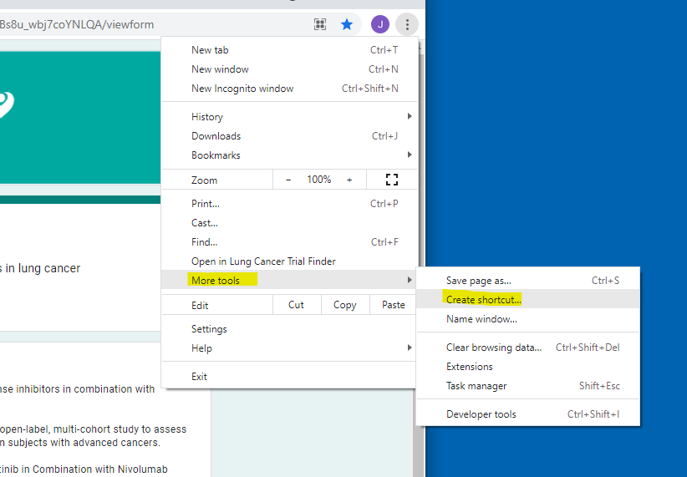

- Enter the name for your shortcut then click ‘Create’.

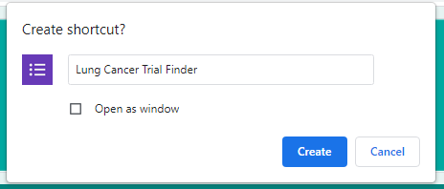

- The link appears on your desktop.

Adding the trial finder to your mobile/tablet

Apple IOS
Click the link below or if it does not open, copy and paste it to your browser. This link is to a YouTube video that shows how to add the trial finder to the home screen of your device.
https://www.youtube.com/watch?v=L_US_-n9qS8

Android
- Open the link to the trial finder in a browser.
- Press the menu button (3 dots in the top-right corner or below the screen).
- Tap ‘Add to Home Screen’.
- The shortcut should be present on the home screen
The video below may help – you may need to copy and paste the link into your browser if you cannot open if from this document.
https://www.youtube.com/watch?v=2HCL9yeoamU

